**Architecture Design**

**Amazon Sales and Revenue**

**Document Control :**

| **Date** | **Version** | **Description** | **Author** |
| --- | --- | --- | --- |
| 16/01/2022 | 0.1 | Introduction & Architecture defined | Digvijay Singh |
| 20/01/2022 | 0.2 | Architecture & Architecture description appended and updated. | Digvijay Singh |

**Content** :

Document Version Control ................................................................................................. 1

1. Introduction .................................................................................................................... 2

1.1 What is Architecture Design Document? ....................................................... 2

1.2 Scope ............................................................................................................. 2

2. Architecture ................................................................................................................... 2

2.1 Power BI Architecture .................................................................................... 2

2.2 Components of Power BI Architecture ........................................................... 3

**1. Introduction** :

* 1. What is Architecture Design Document?

Any software needs the architectural design to represent the design of the software. IEEE defines architectural design as “the process of defining a collection of hardware and software components and their interfaces to establish the framework for the development of a computer system.” The software that is built for computer-based systems can exhibit one of these many architectures. Each style will describe a system category that consists of:

* A set of components (eg: a database, computational modules) that will perform a function required by the system.
* The set of connectors will help in coordination, communication, and cooperation between the components.
* Conditions that how components can be integrated to form the system.
* Semantic models help the designer to understand the overall properties of the system.
  1. What is Scope?

Architecture Design Document (ADD) is an architectural design process that follows a step-by-step refinement process. The process can be used for designing data structures, required software architecture, source code and ultimately, performance algorithms. Overall, the design principles may be defined during requirement analysis and then refined during architectural design work.

**2. Architecture :**

2.1 Power BI Architecture

Power BI is a business suite that includes several technologies that work together. To deliver outstanding business intelligence solutions. Microsoft Power BI technology consists of a group of components such as:

1. Power Query (for data mash-up and transformation)
2. Power BI Desktop (a companion development tool)
3. Power BI Mobile (for Android, iOS, Windows phones)
4. Power Pivot (for in-memory tabular data modelling)
5. Power View (for viewing data visualizations)
6. Power Map (for visualizing 3D geo-spatial data)
7. Power Q&A (for natural language Q&A)

In simple terms, a Power BI user takes data from various data sources such as files, Azure source, online services, Direct Query or gateway sources. Then, they work with that data on a client development tool such as Power BI Desktop. Here, the imported data is cleaned and transformed according to the user’s needs.

Once the data is transformed and formatted, it is ready to use in making visualizations in a report. A report is a collection of visualizations like graphs, charts, tables, filters, and slicers.

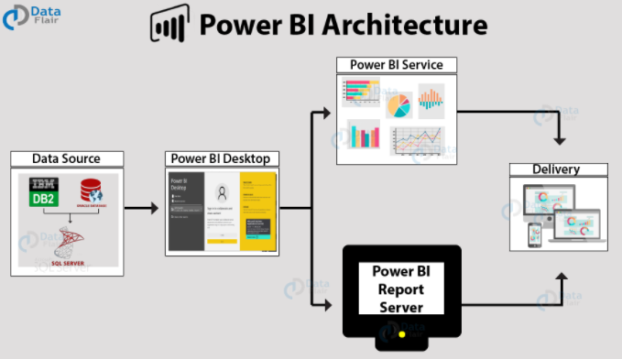

2.2 Components of Power BI Architecture

**1. Data Sources**

An important component of Power BI is its vast range of data sources. You can import data from files in your system, cloud-based online data sources or connect directly to live connections. If you import from data on-premise or online services there is a limit of 1 GB. Some commonly used data sources in Power BI are:

1. Excel
2. Text/CSV
3. XML
4. JSON
5. Oracle Database
6. IBM DB2 Database
7. MySQL Database
8. PostgreSQL Database
9. Sybase Database
10. Teradata Database
11. SAP HANA Database
12. SAP Business Warehouse server
13. Amazon Redshift
14. Google Big Query (Beta)
15. Azure SQL Database

**2. Power BI Desktop**

Power BI Desktop is a client-side tool known as a companion development and authoring tool. This desktop-based software is loaded with tools and functionalities to connect to data sources, transform data, data modelling and create reports.

**3. Power BI Service**

Power BI Service is a web-based platform from where you can share reports made on Power BI Desktop, collaborate with other users, and create dashboards. It is available in three versions:

* + Free version
  + Pro version
  + Premium version

**4. Power BI Report Server**

Power BI Report Server is similar to the Power BI Service. The only difference between these two is that Power BI Report Server is an on-premise platform. It is used by organizations who do not want to publish their reports on the cloud and are concerned about the security of their data.